Factoring 2 7/21

Factor each trinomial:

1) 6x2 + 23x + 7 2) 10n2 - 17n + 7 3) 3x2 + 11x + 6

4) 12y2 + 17y - 5 5) 3x2 + 10x - 8 6) -3x2 + 16x - 16

7) -3x2 - x + 2 8) x6 - 9 9) 16x2 - 40x + 25

10) What value of b would make 3x2 + bx - 8 factorable?

11)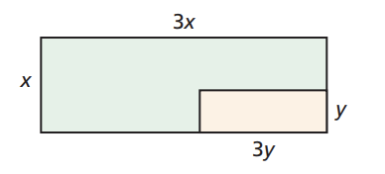

A. What is the area of each rectangle?

B. What is the area of the green region?

C. Factor the expression for the area of the green region. (Hint: First factor out the common factor of 3 and then factor the binomial.)